**Human Activity Detection – Results**

**Jagadeeshwar Reddy Mallepalli**

**700734515**

Ist Screen:

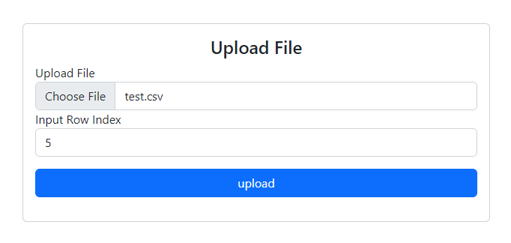

IInd Screen:

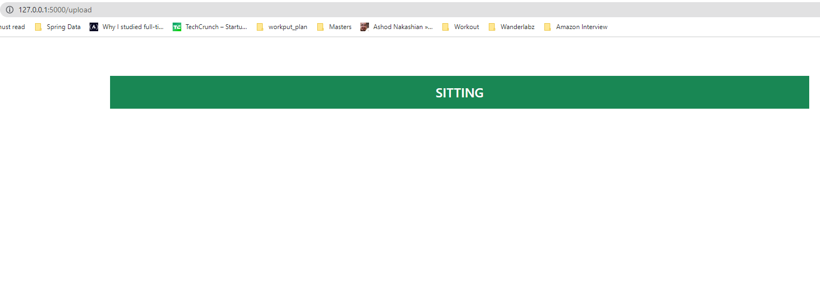

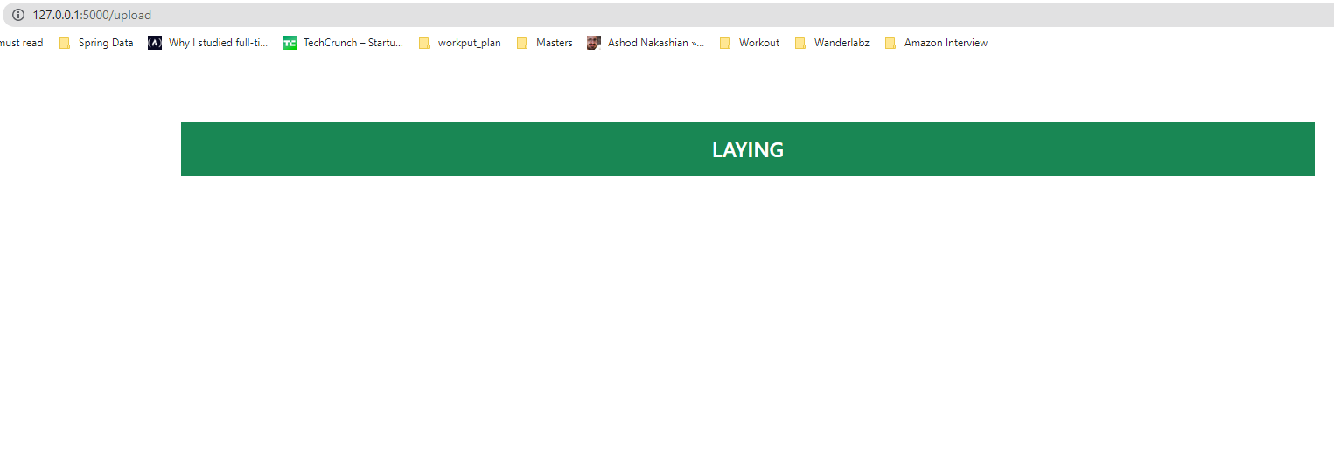

Log Output:

